**BuyRite Pre-launch Consumer Survey (Responses)**

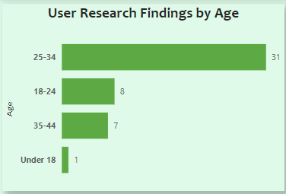

Analysis shows that Agricultural produce has wide range of acceptance from the information garnered from respondents around the country and 1 input from Benin Republic.

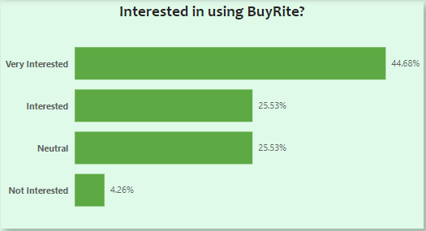

It also suggests that though we did not get much responses, it also points out a task for our product team to ensure acceptability is being increased upon from all regions starting from the country’s epicenter of commerce to the larger part of the country.

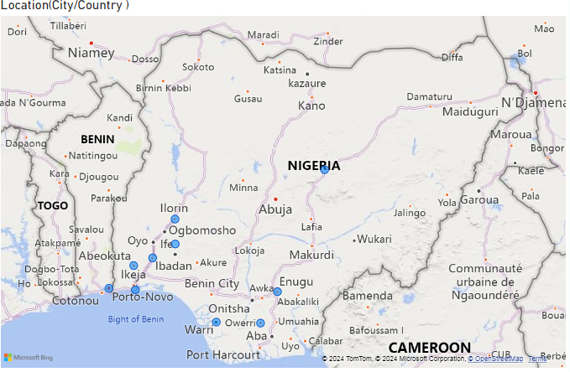



**Primary Concerns when Shopping for Groceries/Produce**

As shown below, the primary concerns indicates that to ensure wide acceptability, freshness of products, fair pricing and trustworthiness of farmers is of optimum priority to respondents. Inflation is rising, which affects all aspects of the country’s economy, we must ensure fair pricing at all times while eliminating middlemen who are the primary drivers of market prices upwardly.

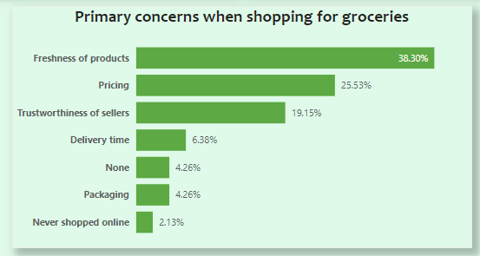

It also opines that farmers profile must be well detailed and up to date, a means of communicating with farmers etc.

Therefore, **software team** are advised to incorporate a message/chat board with farmers, simpler UI/UX that will be well understood by all, option to translate to local dialects etc. so as to ensure that everyone has access and can be able to relate with the app/website.

**Features that interest respondents**

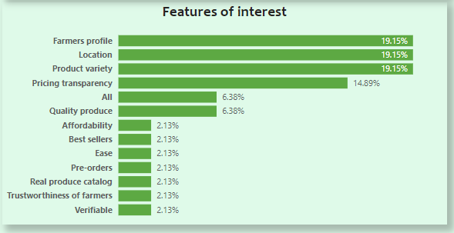

As stated earlier, to ensure **openness**, **farmers** **profile** must be available for reviews by those that are shopping for goods online, **nearness** to the consumers should also be incorporated (**Location** of sellers and buyers), **fair** **pricing** even in the times of higher inflation to ensure **affordability**, product **variety** with **real produce catalog** interest respondents the most during review. Best sellers, star rating will also be an interesting feature.

An intriguing accepts that pin-points farmers profile could be a video feature that lets farmers markets their products and give a brief introduction to what they offer end users

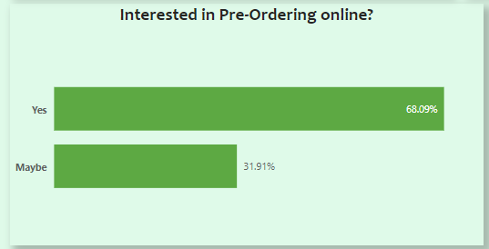

While we should be open to integrate pre-ordering in the future given by the responses, we must first see to the possibility of communication, pricing, transparency, fairness and affordability to ensure ease of doing business, reduce stresses of buying and selling and ensure customers-farmers satisfaction at all times, efficient delivery system if required.

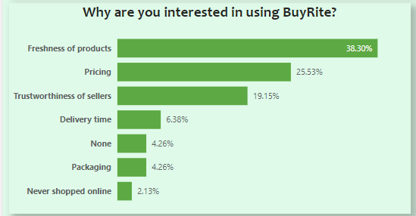

**Respondents’ suggestion**

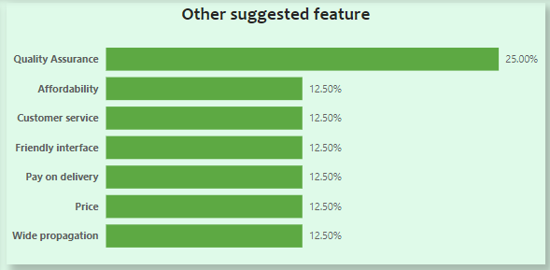

Other features suggested by respondents include, **Quality** assurance which see to the aspect of **freshness** of produce and its quality, **affordability**, efficient **customer** **service** with a **friendly** app **interface**.

Respondents are also open to pay on delivery which publicly available data suggests that we use a cowrie system that will bridge chargebacks frauds, bad or wrong product etc. and to solve that, we must integrate a feature that lets farmers indicates that products has been sent with real time image and also lets buyers to also e-sign or indicate product has been received and certified qualitative with a real time image so that in the advent of customer turnaround, evidence of acceptability is available for reviews at the bank end (Customer service). Therefore, before sellers are being credited, it must be certified by both end while the funds will be on the banks immediate hold for onward processing.

Respondents are optimistic that BuyRite has the capabilities of reduce stresses of going around the markets, convenience and direct access by bridging the gaps between farmers and consumers, with improved/hasten acquisition which invariably reduces produce costs amongst many others.

